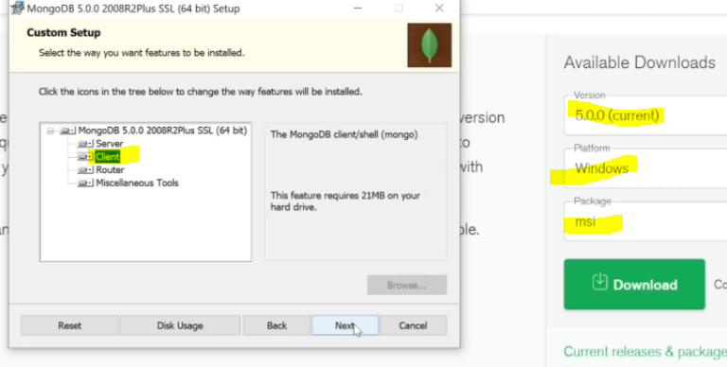

Msi is the installer

Data directory (C:\Program Files\MongoDB\Server\6.0\data\) is where all the mongo db data will be , because ultimately data will be stored locally in files, after u un install u can delete everything in this folder

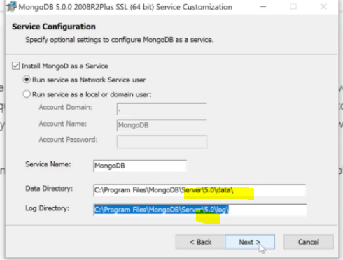

Once downloaded , make sure in services.msc below is running

## Ensure Mongo server

This is a mandatory step – make sure this is running before u start executing commands in shell

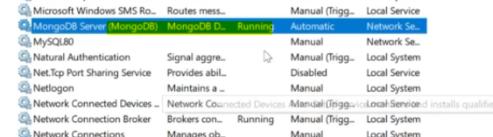

**C:\Program Files\MongoDB\Server\6.0\bin**

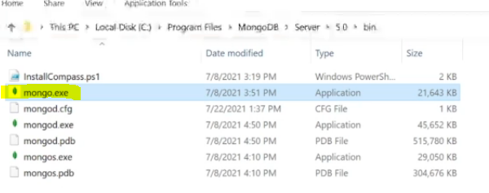

**this mongo.exe is the client where it will send commands to server**

**we will run the commands in it is mongosh.exe or mongo.exe**

# install mongodb shell

<https://www.mongodb.com/try/download/shell>

install the shell and move those 2 softwares to where mongod is there

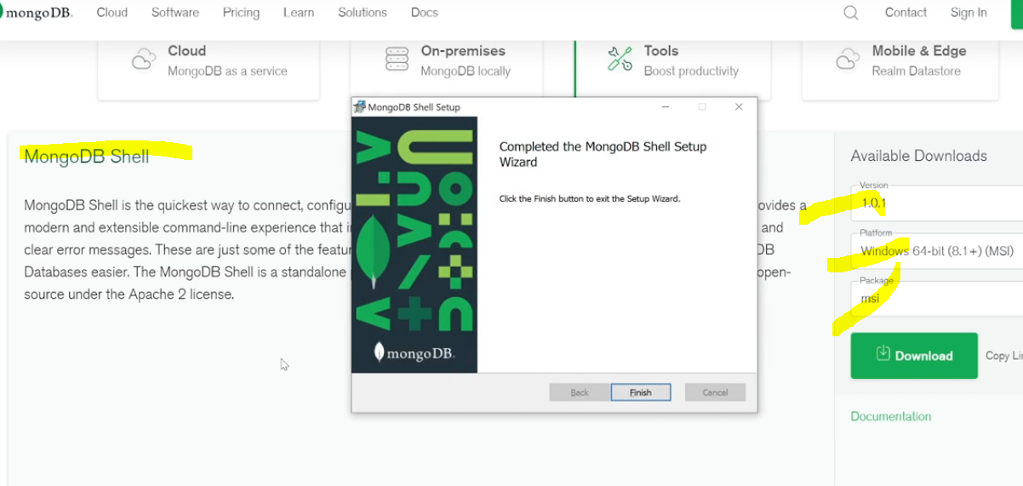

After installing new mongo latest shell

E:\study softwares\mongosh-1.6.1-win32-x64\mongosh-1.6.1-win32-x64\bin

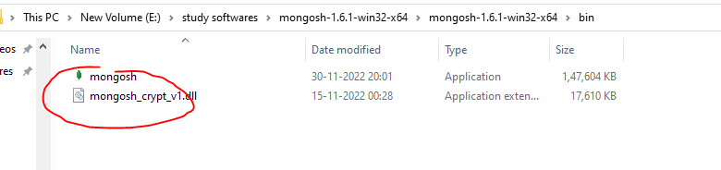

Copy paste these files to the folder where mongod is present

Mongoshell also connects to mongo server this is just a CLI

### Mongo import

In this course, we'll also use another tool called mongoimport. It's a tool / local command which we will occasionally use in this course to import some prepared data into a MongoDB database.

Since it wasn't installed together with the MongoDB server + client, you need to install it as a separate tool, following the installation instructions you find here (or use the links below): <https://docs.mongodb.com/database-tools/installation/installation/> (these "Database tools" contain the mongoimport tool / command).

Windows Installation: <https://docs.mongodb.com/database-tools/installation/installation-windows/#installation>

macOS Installation: <https://docs.mongodb.com/database-tools/installation/installation-macos/#installation>

Linux Installation: <https://docs.mongodb.com/database-tools/installation/installation-linux/#installation>